**NAME: AHSAN SAJJAD**

**SECTION: BSE-3B**

**ASSIGNMENT # 01**

|  |  |  |
| --- | --- | --- |
| **C:\Users\AHSAN\AppData\Local\Temp\ksohtml16076\wps1.jpg** | **BAHRIA UNIVERSITY, (Karachi Campus)**  *Department of Software Engineering*  **Assignment 1 - Fall 2022** |  |

COURSE TITLE: **INTRODUCTION TO PSYCHOLOGY** COURSE CODE: **PSY-102**

Class: **BSE-V & III** Shift: **Morning**

Course Instructor: **Marvi Makhdoom** Time Allowed:  **2 Weeks**

Submission Date: 3rd NOV, 2022 Max. Marks: **5 Marks**

**Question No. 1 [CLO1: 5 Marks]**

Students are requested to write about the psychological theory/perspective or school of thought that they think best define human behavior or mind. You should come up with the evidences, real life examples or past researches to back up your claim/s. (Min 200- 400 words)

ANSWER:

The five major perspectives in psychology are **biological, psychodynamic, behavioral, cognitive and humanistic.**

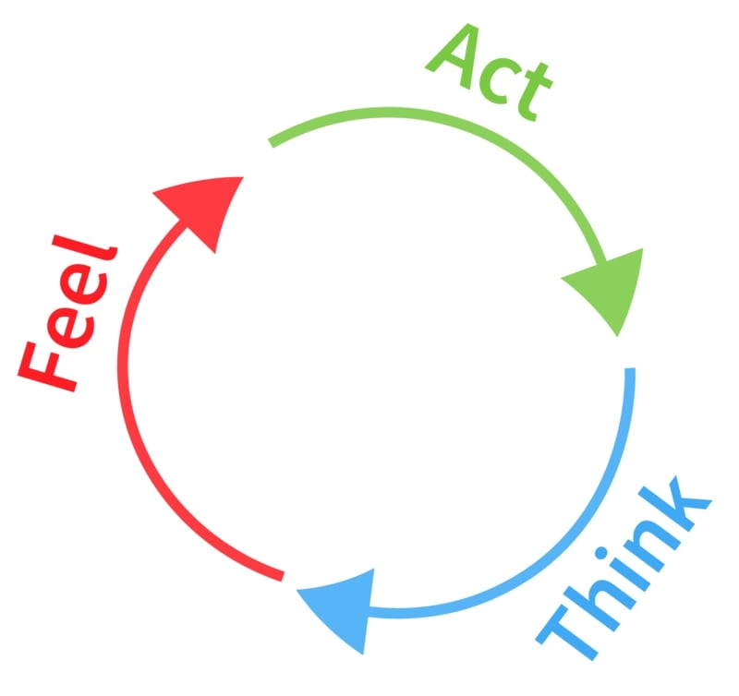

**Major Schools of Thought in Psychology**

* Structuralism.
* Functionalism.
* Gestalt psychology.
* Behaviorism.
* Psychoanalysis.
* Humanism.
* Cognitive Psychology.

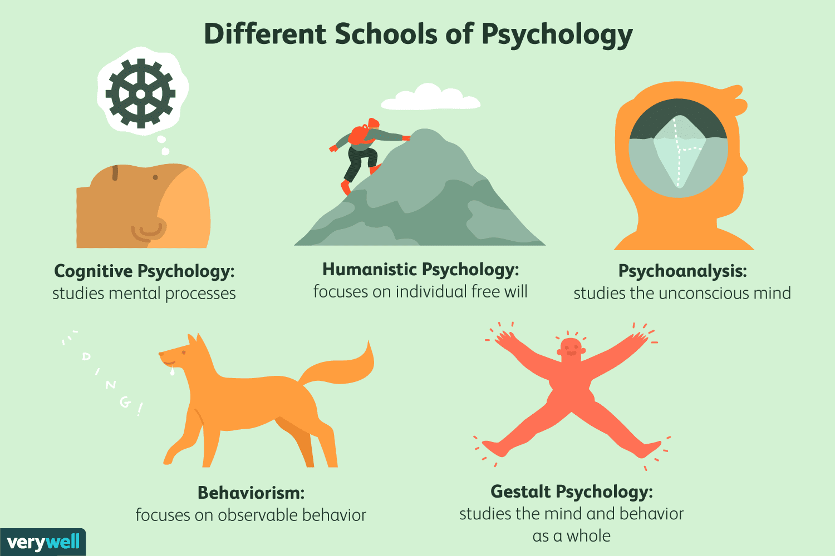

A **perspective** is a point of view or a specific way of looking at something. For example, if a person was robbed on the subway, their subsequent perspective of the subway may be vastly different from someone else who didn't have that same experience. A **psychological**

**Perspective** is the same in that it's a specific focus or way of viewing something, but in psychology specifically, the focus is based on observing behaviors. Essentially, a psychological perspective is a specific approach to observing and understanding human behavior which can contain various theories.

While each perspective takes a different approach to understand human behavior, all approaches are attempting to understand the ways the brain works and why humans act the way they do. For example, take the concept of aggression. When looked at through the lens of evolution, a scientist may say aggression is a trait that has helped humans stay alive, hunt, and evolve. However, the psychodynamic perspective may suggest that aggression is no longer needed and connects to trauma or disruption in a person's individual childhood experiences.

There is no right or wrong perspective when it comes to psychology, as all approaches have strengths and weaknesses, but using various perspectives can help researchers understand why a person may choose to behave a certain way and or why a group of humans make the same choices in a given situation.

**The 6 Psychological Perspectives**

When it comes to psychological perspectives, there are 6 psychological perspectives that are most often used. These contemporary perspectives in psychology are newer to the field, as most early psychologists focused on schools of thought instead. Today, modern psychologists focus on perspectives when it comes to their research, allowing approaches to shift and overlap.

Read on to learn about the 6 main psychological perspectives and what they bring to the table in psychological research.

**Psychodynamic Perspective**

The **psychodynamic perspective** is an approach developed by famed psychologist Sigmund Freud. Freud believed that human behavior connected to drives and forces within the body and mind, most of which were unconscious workings. He also felt these drives were prominent in childhood and that difficulties at different stages of development would shape a human's personality later in life.

Freud developed this theory based on his work with hundreds of patients suffering from anxiety and depression and noticed that most of the trauma suffered stemmed from issues in childhood. He believed if he could get to the root of the behavior through means such as talk therapy and dream interpretation, he could cure his patients.

**Biological Perspective**

The **biological perspective** focuses on a person's genetics and literal biology as a way to understand human behavior. Researchers using this approach look at the brain and the body through MRIs, PET scans, and genetic variables in blood panels to assess personality and individual choice.

|  |
| --- |
| The biological perspective looks to the body for answers. |
| ***Psychologists who use the biological approach use tools such as MRIs and PET scans to look inside the body for answers regarding behavior.*** |

In this approach, researchers often create and use various pharmaceutical drugs to further research and help patients with issues, such as depression, anxiety, and chemical imbalances. Through major advancements in technology, scientists have mapped the brain and can physically see changes and shifts based on trauma and environmental factors.

**Cognitive Perspective**

The **cognitive perspective** looks at the brain as a computer, insofar as it's an information processor. This approach aims to understand functions, such as memory, language, attention, and thinking to name a few. Researchers using this approach create information-processing models to better understand behavior, moving away from the idea of conditioning or childhood trauma.

Many didn't like the cognitive perspective because instead of looking at physical behaviors a person can see, these scientists were aiming to understand the inner workings of the brain that can't be observed. Instead of simply looking at behavior, researchers asked why the behavior occurred and how. Many believe psychologist Albert Bandura bridged the gap between behaviorism and the cognitive perspective, as his Social Learning Theory didn't simply focus on conditioning. He felt while behaviors could be and are conditioned responses, there was a process happening behind the scenes that showcased how and why learning occurred, too.

**Evolutionary Perspective**

The **evolutionary perspective** looks at human behavior through the process of evolution. It maintains that the human body and mind have both evolved over time to better fit their environments and adapt to survive. While the perspective agrees that biological components are the key to understanding and that the brain does, in fact, use information processing, it posits the changes in behaviors are all adaptations that have occurred over time to allow the species to survive and reproduce.

|  |
| --- |
| Evolutionary perspective believes adaptations are what cause human behaviors. |
| ***Evolutionary psychologists believe current human behaviors occurred because of evolution as a way to adapt to an ever-changing environment.*** |

That's not to say traits such as instincts don't exist, but it does mean that those instincts, the unconscious drive to do something without thinking, are part of the evolutionary landscape. By looking at behavior changes over time, and the corresponding genetic components, researchers feel they can gain a better understanding of human behavior and personality traits.

**Humanistic Perspective**

The **humanistic perspective** focuses on an individual as a whole, looking at all aspects of a human's life. This includes their biology, environment, the way their brain works, and their ancestral lineage. The underlying philosophy of the approach centers on free will and the idea that all humans have the capability to change and grow.

Abraham Maslow's work paved the way for this approach, as it focused on a hierarchy of needs he felt every person could work to gain and achieve. His work, depicted as a pyramid, layered the necessary physical and mental challenges humans would encounter on their way to his understanding of enlightenment. He felt if a person could get the basic necessities and safety to live, they would find more motivation along the way and work towards a positive self-image that reflects a healthy and happy individual.

From this research and theory, humanism was born to rebel against the other approaches that many felt were restrictive and caused harm through broad grouping and stereotyping.

**Behaviorist Perspective**

The **behaviorist perspective** looks at a person's environment as a cause of how and why a person behaves in a certain way. Behaviorists believe that all behaviors are learned and focus on the things they can see instead of what they can't inside the brain/body.

# **More Peoples Involved in Past Researches:**

## Edward Thorndike

Thorndike is best known for his work on learning theory, which B.F. Skinner drew on to theorize operant conditioning in humans. Thorndike developed the ‘law of effect’ which states that satisfying responses in one particular situation become more likely to occur again in the same situation. Thorndike studied learning theory with cats who attempted to get out of a box using different methods. He found that those who noticed a lever which would enable them to get out of the box would push the lever again when put back in the box. This experiment became a basis for operant conditioning.

## Burrous Frederic (B.F.) Skinner

Skinner was a foundational figure for the behavioral perspective. Skinner thought that classical conditioning was too simplistic as an explanation for all of human behavior and was interested in not only the cause of an action, but also the consequences. He found that behavior that is reinforced through rewards tends to be repeated, whereas behavior which is not reinforced or that which leads to punishment tends to die out. He called this kind of conditioning operant conditioning.

## Clark Hull

Hull believed that human behavior could be explained by conditioning and reinforcement. His theory rested on the concept of homeostasis: he suggested that human motivation arises as a result of biological need. When thirsty, hungry, or tired, Hull claimed that people feel a ‘drive’, defined as tension or arousal, which causes them to behave in ways that will reduce their drive.8 Hull published these theories in Principles of Behavior in 1943.

## Kenneth Spence

Spence was Hull’s student and helped him develop his ideas on learning and drive. He took ideas about operant conditioning a step further by suggesting that a response is in fact influenced by the size or value of a reward. For example, if money is being used as an incentive, the amount of money will impact the likelihood of a person exhibiting the desired response. Spence thus suggested that performance depends on reinforcement, as well as motivational incentives.

**Examples of Real Life:**

## Positive Reinforcement:

* The teachers reward their class or certain students with a party or special treat at the end of the week for good behavior throughout the week.
* Parents often use a reward system when putty training a toddler. Each time a child does a desirable behavior — for example, sitting on the putty, having a dry diaper in the morning, or going to the bathroom on the putty — the parent gives the child a reward, such as a sticker or piece of candy. The hope is that the child will continue to exhibit the desired behavior because of the reward until it eventually becomes a habit.
* A customer writes a letter of appreciation praising a team member. The boss praises the employee the letter was about in the staff meeting and adds a $50 bonus to the employee's paycheck. This is positive reinforcement for exceeding customer expectations.
* A person who contributes an idea is praised for doing so, even if the idea isn't one that is feasible. Because the person knows his or her efforts were appreciated, the individual gladly continues contributing suggestions and ideas.
* Four-year-old Asha has a chore chart that includes such behaviors as making her bed, getting dressed, brushing her teeth, and taking her breakfast plate to the sink. If she completes her chores, she earns a sticker on her chore chart. Once she has five stickers, she gets to pick what the family will have for dessert.

## Negative Reinforcement:

* Employees who don't meet their weekly sales quota are required to submit a report explaining why they missed the quota and what they will do differently next week. An employee who dislikes writing reports may be motivated to work harder to make their quota to avoid having to write a report.
* Ahmed's mother gets angry and yells at him when he forgets to do his chores. He doesn't want to get yelled at, so he makes a point of remembering to complete his chores.
* Jill really doesn't like working out, but she knows that her bones and joints will ache if she doesn't exercise regularly. She continues exercising regularly to keep from experiencing this undesired consequence.

## Punishment:

* Sarah is in the habit of speeding on her way to work. One morning, she gets stopped by a police officer and given a $275 speeding ticket. After that, she never speeds again. The fear of getting another ticket and having to pay even more of her hard-earned cash is enough of a deterrent to keep her from speeding again.
* Student-athletes are required to maintain at least a grade of a B in every class in order to participate in their various sports. If a grade drops below a B, the athlete will not be allowed to compete until he or she improves the grade. The punishment of having to sit out of games can motivate students to quickly do what is needed to improve his or her grade.
* If a high school student is late to school more than three times in a marking period, he or she will earn a detention and have to stay after school. School officials hope that the possibility of having to serve time in detention will encourage students to arrive at school on time.
* When people try to break themselves of bad habits, they sometimes put a rubber band on their wrist and snap it whenever they catch themselves doing what they want to stop. If someone who swears a lot does this every time a term they shouldn't use comes out, it just might be punishment enough to stop the behavior.
* The teacher take away certain privileges if the student misbehaves

**THE END**